WEEK 2:
Market:
- A group of buyers and sellers of a particular good or service.
- Buyers demand ; sellers supply
  - Organized market homogenous place, where buyers and sellers meet at a specific time and place.
  - Unorganized market sellers are scattered – offer slightly different products, and buyers choose where to purchase.
  - Competitive market many buyers and sellers. Price is determined by the market as a whole – buyers have negligible impact on the price.
  - Non-competitive market
    - Monopoly : a single seller sets the price.
    - Oligopoly: market dominated by a small number of large firms.
Demand:
- Quantity of goods/services that consumers are willing and able to buy at different prices during a given period of time.
- Demand has to be backed by purchasing power.
- Law of demand:
  - When the price of a good rises, the quantity demanded of the good falls; when the price falls, the quantity demanded rises.
- Demand schedule table that displays the relationship between the price of a good and the quantity demanded
- Demand curve graphical representation of the demand schedule.
It slopes downward because a lower price naturally increases the quantity

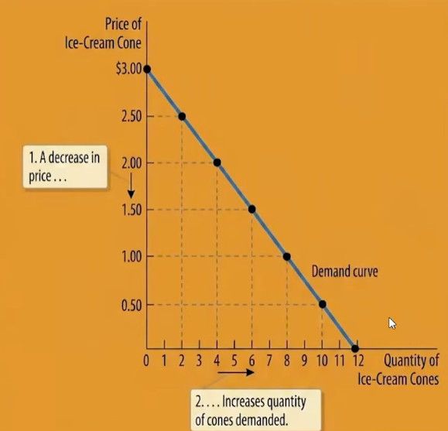
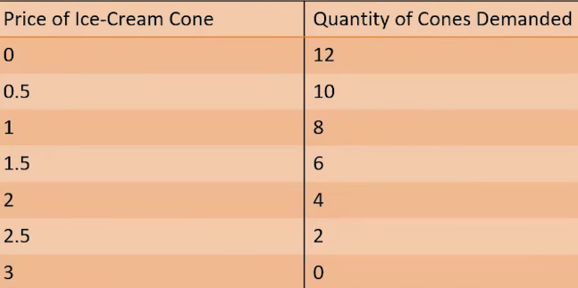

- Market demand sum of all individual demands for a product.
- Quantity demand sum of quantities demanded by the buyers at each price

Supply:
- The quantity of a good or service that producers are willing and able to offer for sale at different prices during a given period of time.
- Law of supply:
  - When price of a good rises, the quantity supplied also rises; when price falls quantity supplied falls.
- Supply schedule: relationship bw price and quantity
- Supply curve: plotting supply schedule
- Market supply: aggregate of all individual sellers in the market
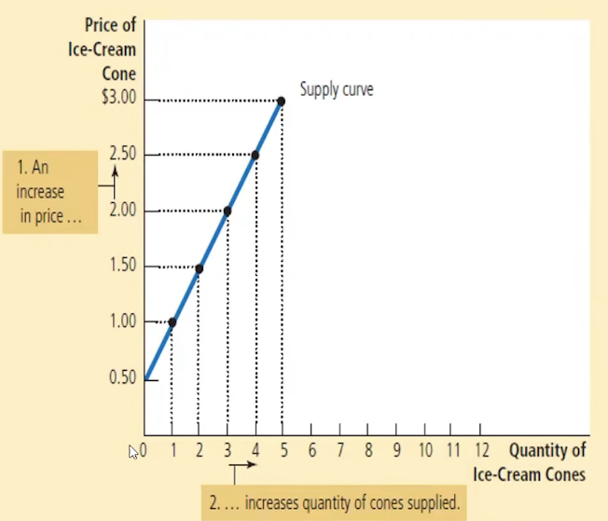
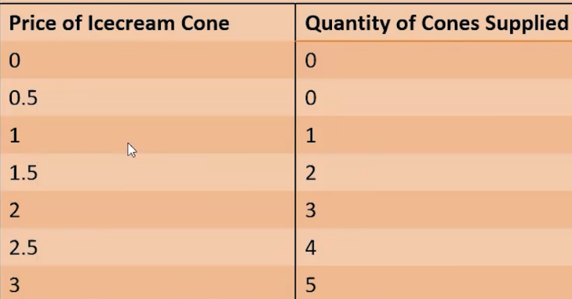

Shifts in Demand Curve:
- Increase in Quantity demanded increase in demand
- Decrease in quantity demanded decrease in demand

- Key variables:
  - Income: higher income increases demand for normal goods.
    - If demand rises when income falls, it’s an inferior good.
  - Price of related goods:
    - Two goods are substitutes if a fall in price of one reduces the demand of the other
    - Two goods are complements if a fall in price of one increases the demand of the other
  - Preference/ tastes:
    - Positive preferences increase demand
  - Future expectations
  - Number of buyers: increase in the number of consumers increases market demand.
Shift in Supply curve
- Key variables:
  - Input prices: if input prices rise, production becomes less profitable
  - Technology: advancement in tech reduces labour costs and increases supply of good
  - Expectations: if a firm expects market price to rise, it might store some of its current production, reducing supply availbe to market
  - Number of sellers: if sellers leave the business, market supply will decrease.
- Equilibrium: Price has reached level where quantity supplied = quantity demanded.
- Equilibrium price: price that balances quantity supplied and demanded
- Equilibrium quantity: quantity supplied and demanded at equilibrium
  - surplus: market price above equilibrium price surplus occurs because quantity supplied > demanded
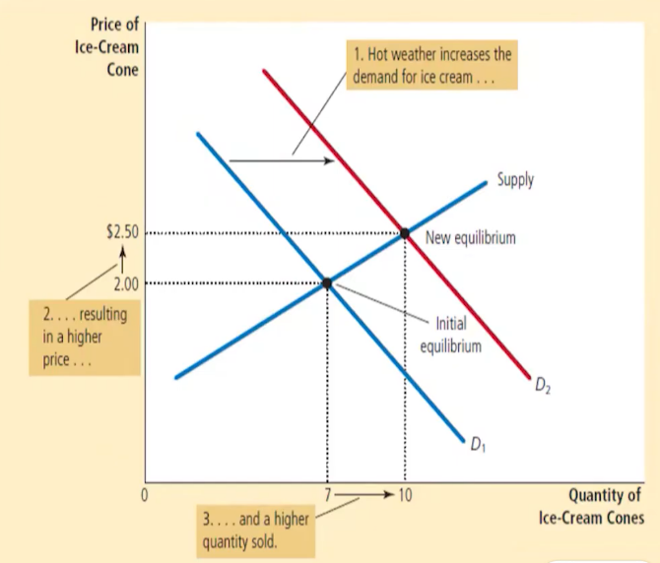
  - shortage: quantity supplied < demanded
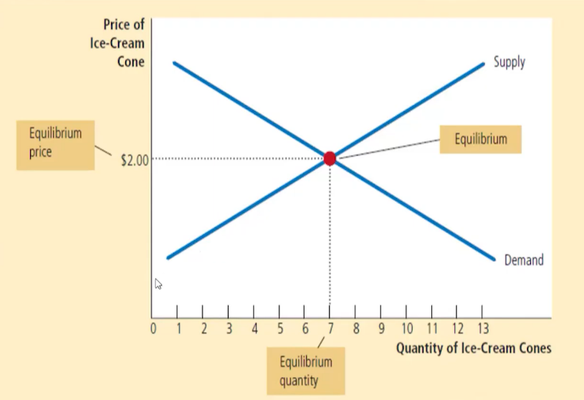
Elasticity of demand:
- Elasticity: degree of responsiveness of one variable to changes in another
- Price of elasticity demanded: measures how much quantity demanded changes as a response to a change in price
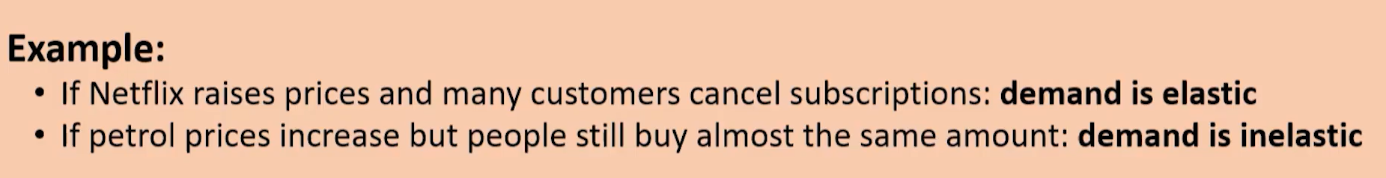
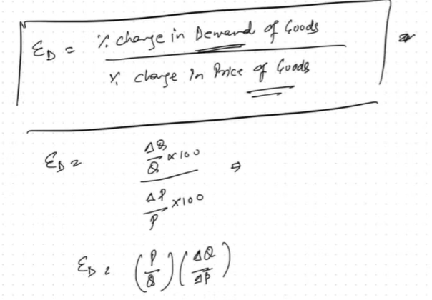
Determinants of elasticity:
- Availability of close substitutes
- Definition of markets: narrowly defined markets are more elastic easier to find close substitutes
- Necessities vs luxury: necessities are inelastic. Luxury is elastic
Time horizon:
- Goods tend to have more elastic demand over a longer time horizon.
Price elasticity of demand:
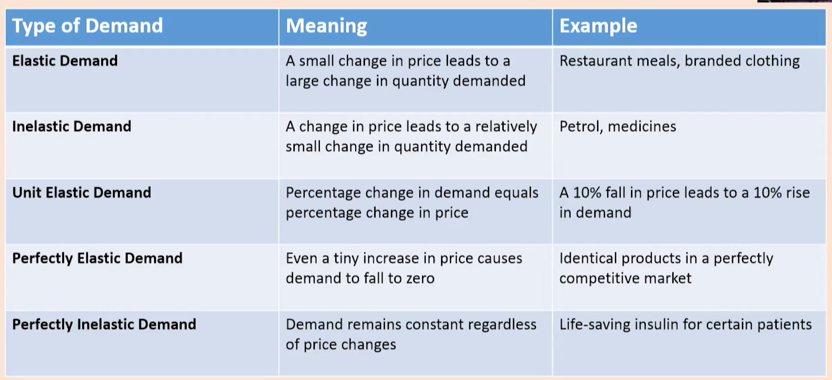
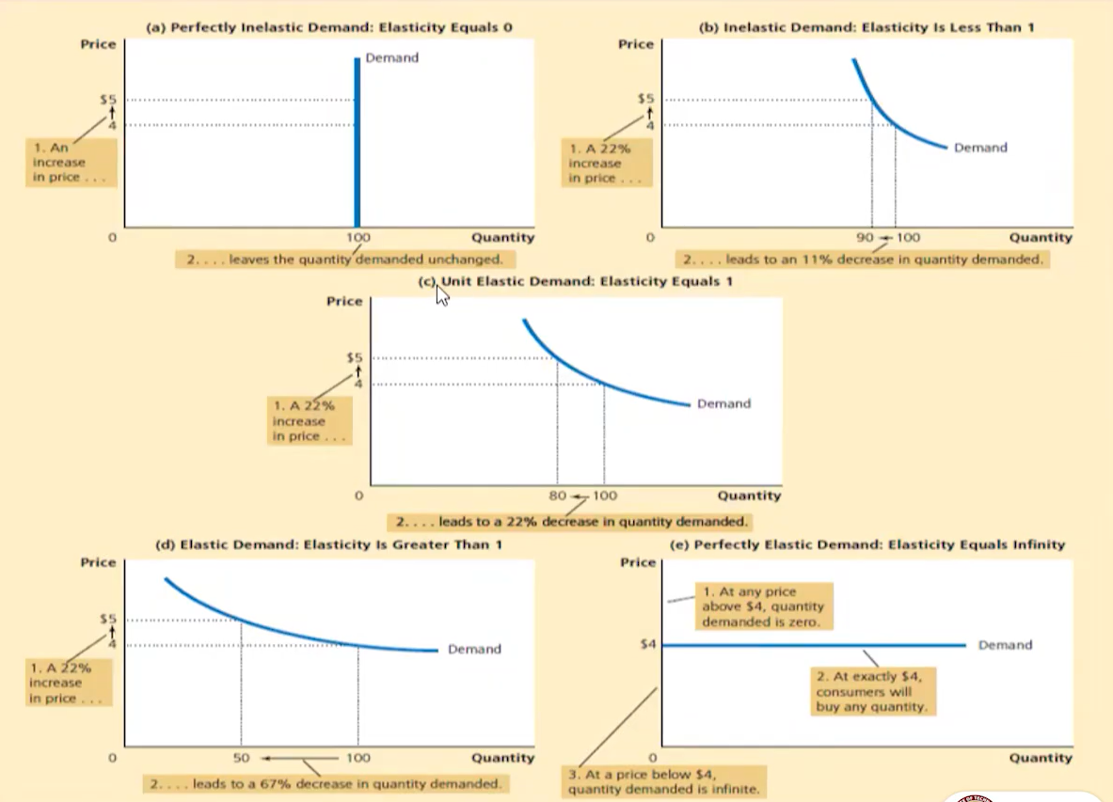
Total revenue = P x Q P price of good
Q quantity sold
- Elastic demand: decrease in revenue
- Inelastic demand: increase in revenue
- Unit elastic demand: revenue remains constant

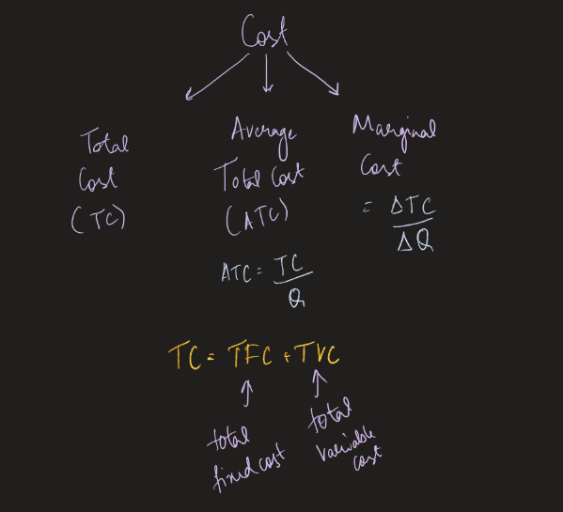

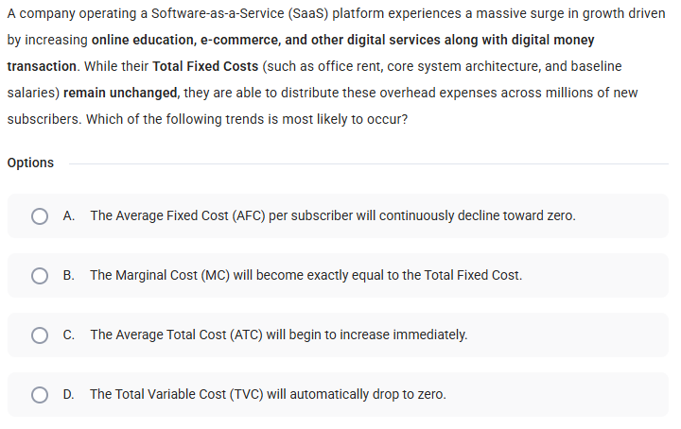

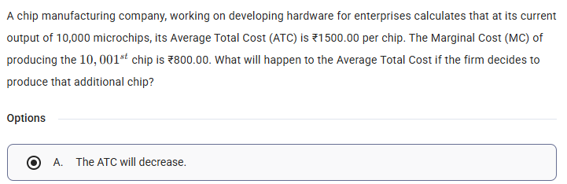

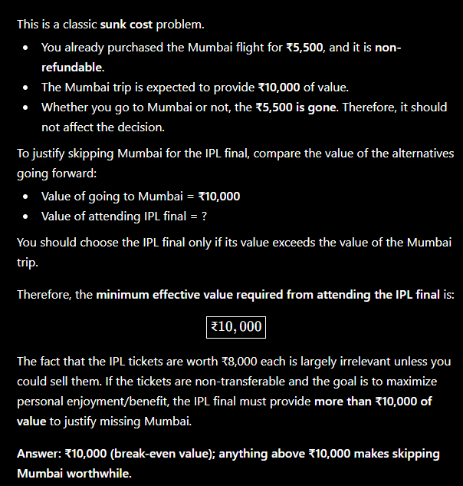
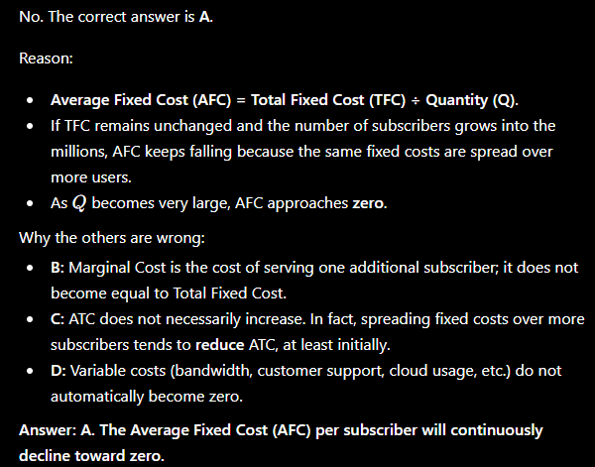
PPF – Production Possibility Frontier
- Graphs the maximum possibility combination of two goods an economy can produce when all resources are fully and efficiently utilized.
- Points on the curve represents productive efficiency
- Points inside the curve represents inefficiency of resources (wasted materials)
- Points outside the curve resources currently unattainable

- As you shift resources from one good to another you must give up increasingly larger amounts of the first good because resources are not equally suited for producing both goods
- Assumptions:
  - Input fixed
  - Resources are fully utilised
  - Technology and other conditions are fixed
- Marginal opportunity cost (MOC) =

Shifts in PPF:
- Rightward shift
Due to advancement/ tech upgrade

- Leftward shift:
Due to insufficient resources

Rotation in PPF:
- Fixing the y point – changing the x point
PPF: Concept of efficiency output/input
  - Efficiency > 100% over utilisation of resources
  - Efficiency = 100% no wastage of resources
  - Efficiency < 100% underutilisation of resources

